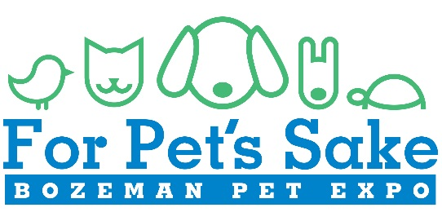
Pet Rules & Waiver for 2017
I wish to bring my pet to For Pet’s Sake: Bozeman Pet Expo hosted by Bozeman Daily Chronicle.
I agree to the following: I acknowledge that my pet is up to date on all age appropriate vaccinations, is not of an aggressive nature, is not in heat and is free from contagious diseases or conditions that would make it a danger to any participant, spectator, other animal or other individual.
Without exception, I accept full financial responsibility for any bodily injury or damage to persons or properties as a result of my pet’s actions at this event.
I understand that the For Pet’s Sake: Bozeman Pet Expo, Gallatin County Fairgrounds and Bozeman Daily Chronicle, it’s employees, owners, members, managers, officers, volunteers and representatives and any other individual or professional entities involved with the production of this event, reserve the right, in their sole and absolute discretion, to refuse admittance to any unruly, aggressive, unsuitable or obviously ill pets. In addition, I also know that my pet may be asked to leave the event if it displays behaviors that are deemed by Bozeman Daily Chronicle personnel to be disruptive or dangerous.
I affirm that I am the ONLY one responsible for my pet and agree to indemnify and hold harmless any other person, company or organization from liability resulting from my pet’s attendance at this event.
My pet is:
- Properly fitted with a collar and 6-foot or less, nonretractable leash
- Not of an aggressive nature
- Domesticated and up-to-date on all age appropriate vaccinations
I will pick up my pet’s solid waste as a courtesy to others and dispose of it in the on-site receptacles.
I understand that this Release Agreement is a contract and that I have read all of its terms, fully understand them, am a legal adult (age 18 or older) and am legally competent to execute this release form. By signing this form, I give For Pet’s Sake: Bozeman Pet Expo and Bozeman Daily Chronicle permission to email me with pet expo updates. Under no circumstances will my information be sold to outside parties.
Complete one form for each pet attending the event.

Pet’s Name_________________________________ Age ______________ Breed ____________________
Owners Name (Print) _______________________________________________ Date ________________
Email Address ____________________________________________ Phone Number ________________
Signature_____________________________________________________________________________

